As tourism is one of the fastest growing industries today, thus within the tourism industry events are getting more and more important. People have become more interested in events of all kinds, and will travel far away to participate in events that they find interesting. It has become widely accepted that every community and destination needs to adopt a long-term, strategic approach to event tourism thereby planning and development in order to realise the full tourism potential of events. This study was launched as a response to the lack of studies on how Tours strategies are actually used in destinations. The study was directed to tours and travel management system and the aim was to explore Tour and Travel packages. We provide the most suitably designed as well as the customized travel packages to the customers. We offer everything related to travelling services under one roof.

.

**SI. NO TITLE PAGE NO.**

|  |  |  |  |
| --- | --- | --- | --- |
| ACKNOWLEDGEMNT ABSRTACT  CONTENT  **1. INTRODUCTION** |  |  | i ii  iii  **01** |
| 1.1 Problem Statement |  |  | 01 |
| 1.2 Motivation |  |  | 01 |
| 1.3 Objectives |  |  | 02 |
| **2. REVIEW OF LITERATURE** |  |  | **03** |
| 2.1 MakeMyTrip |  |  | 03 |
| 2.2 Trivago |  |  | 03 |
| 2.3 Ibibo |  |  | 04 |
| **3. FUNCTIONAL REQUIREMENT SPECIFICATION** |  |  | **05** |
| **4. ANALYSIS AND DESIGN** |  |  | **06** |
| 4.1 Architecture |  |  | 06 |
| 4.2 Use Case Diagram |  |  | 07 |
| 4.3 Entity Relationship Diagram  4.4 Schema Diagram  **5. SOFTWARE AND HARDWARE REQUIREMENTS** |  |  | 08  09  **10** |
| **6. IMPLEMENTATION** |  |  | **11** |
| **7. RESULTS & TESTING** |  |  | **14** |
| 7.1 Results |  |  | 14 |
| 7.2 Testing |  |  | 18 |
| **8. CONCLUSION AND FUTURE ENHANCEMENTS** |  |  | **20** |
| **REFERENCES** |  |  | **21** |
| **APPENDIX** |  |  | **21** |

**CHAPTER – 1**

# INTRODUCTION

Tourism is travel for pleasure or business; also the theory and practice of touring, the business of attracting, accommodating, and entertaining tourists, and the business of operating tours. Tourism may be international, or within the traveller's country. It is said that "traveling to and staying in places outside their usual environment for not more than one consecutive year for leisure and not less than 24 hours, business and other purposes".

By Tourism management system one can easily access all the details such as weather, location, events, etc. Nearly everyone goes on a vacation and a Tourism management system would play a vital role in planning the perfect trip. The tourism management system allows the user of the system access all the details such as weather, location, events, etc. The main purpose is to help tourism companies to manage customer and hotels etc. The system can also be used for both professional and business trips.

The proposed system maintains centralized repository to make necessary travel arrangements and to retrieve information easily.

## Problem Statement

In the absence of Online tourism websites, their arise many problems such as: unawareness of the weather conditions of the place, difficulty in exploring new location and nearby places, difficult to find hotels for stay in those unknown locations. It will also be time consuming for the customers to manually go to the agencies and book their trips. The cost of the trip can also be made reasonable by providing the comparisons. So, we provide these facilities by creating a platform for Online tourism management system to customers.

## Motivation

With the advancements taking place in the web technologies department, it has become important for any business to have their own web application on desktops and smartphones and travel & tourism industry is not an exception.

A huge part of the success of travel & tourism industry has been played by the web application users.

* + - Automation

With all the information being available instantly, people can look for whatever they want without talking to anyone about the same. From a business point of view, all the operations like bookings, information, billing, invoicing, and every other thing is automated which leads to saving time and effort.

* + - Security

Travel & Tourism web applications are developed taking all the measures and implementations which make it safer and secure both clients and business owners. Therefore, Travel & Tourism companies should hire a good web application development company for developing a secure website.

* + - One Solution for Everything

A travel & tourism web application should act as a single web application for booking tickets, hotels, sightseeing, car rentals, and sometimes travel related shopping as well. Moreover, for all these, you are not required to create a single portal for each of them.

So, these days web application for travel & tourism is lame without a web application. Security is the main reason for every web application out there. Therefore, the options have to be wisely chosen for making the travel & tourism web application a successful one.

## Objectives

The objective of the project is to,

* + - Develop a system that automates the processes and activities of a travel and tourism agency.
    - Design a system using which one can perform operations related to traveling and sight- seeing.
    - Make users choose the places they want to visit and make bookings online for traveling and accommodation.

**CHAPTER – 2**

# REVIEW OF LITERATURE

## MakeMyTrip



MakeMyTrip Limited is an Indian online travel company, founded in 2000. Headquartered in Gurugram (also known as Gurgaon), Haryana, the company provides online travel services including flight tickets, domestic and international holiday packages, hotel reservations, rail and bus tickets.

MakeMyTrip offers flight tickets, rail and bus tickets, cab service and hotel booking services on its portal. In 2012, MakeMyTrip launched travel mobile application for Windows Phone, iPhone, Android and Blackberry devices. MakeMyTrip route planner provides all the basic required information on more than one million routes in India.



## Trivago

Trivago, is a German transnational technology company specializing in internet-related services and products in the hotel, lodging and meta search fields. The services they provide are,

*Hotel search*: Trivago's hotel search engine was the first of its kind in Germany and has websites in 50 plus countries. Trivago claims to be the world's largest online hotel search site, comparing rates from over one million hotels and more than 250 booking sites worldwide. Trivago's search tool scans hotel booking sites for prices, availability, images and reviews within seconds. When users choose a hotel, they are redirected to a partner website to complete the booking.

*Trivago app:* It offers a free app for its Hotel Search product on both iOS and Android. In addition to the hotel search feature, the app provides interactive maps and displays accommodations in close proximity to the user's current location.

*Trivago Hotel Manager:* Hotel Manager is Trivago's B2B platform that allows hoteliers to market their facilities on the Trivago site. The platform gives hotels and chains customer data to attempt to secure more bookings and increase business. Hoteliers can monitor their performance, for example seeing the amount of profile views, clicks and bookings they receive.

## Ibibo



Ibibo Group is an online travel organization founded in January 2007 by Ashish Kashyap. The company is a subsidiary of MakeMyTrip Limited, Mauritius which owns an 100% stake in Ibibo Group. The group owns the B2C online travel aggregator Goibibo, and online bus ticketing platform Redbus.in. In 2013, ibibo Group was named one of the top five most trusted e-commerce brands in India in The Brand Trust Report India Study – 2013.

**CHAPTER – 3**

# FUNCTIONAL REQUIREMENT SPECIFICATION

#### Functional requirements of Admin

* + - * Can login with particular user name and password.
      * Can create and manage tour packages.
      * Can view and manage the list of passengers.
      * Can view and respond to issues and enquires.

#### Functional requirements of Users

* + - * Can register and login to their account.
      * Can view the tour packages.
      * Can book the packages by giving their name, Email id, phone number.
      * Can cancel the booking if necessary.
      * Can enquire the admin about packages.

**CHAPTER – 4**

# ANALYSIS AND DESIGN

## Architecture

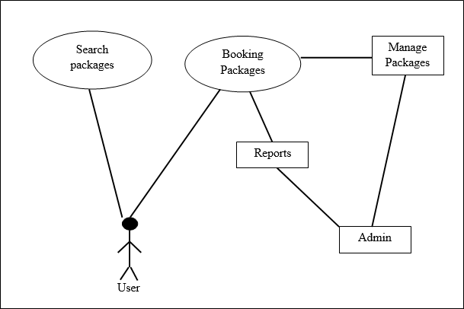

##### Fig 4.1: Architecture of Tourism Management System

The fig 4.1 illustrates the architecture of the system. The user have the privilege to search the packages and book the packages. The admin views the bookings and he can manage the packages.

## Use Case Diagram

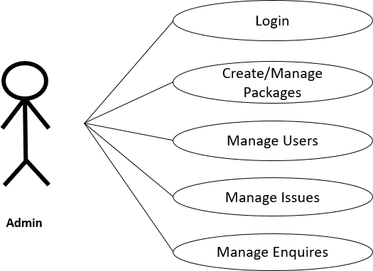

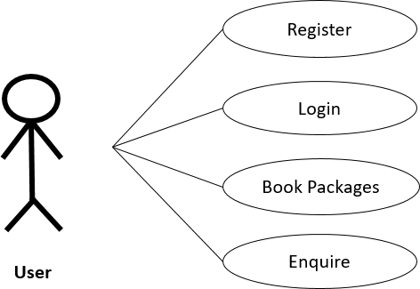

##### Fig 4.2: Use Case Diagram of Tourism Management System

Fig. 4.2 depicts the use case diagram of both the user and the admin. The diagram explains the role of each individual type of users. The admin can login and manage the packages, issues, bookings and enquires. Whereas the user’s role is to register, enquire, view the packages and book them.

## Entity Relationship Model

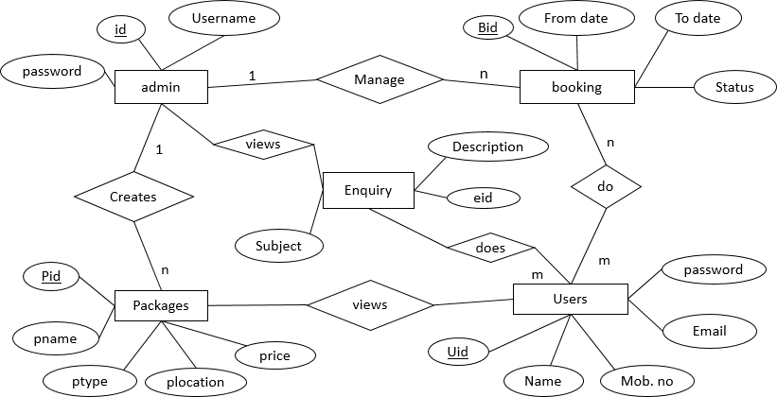

##### Fig 4.3: Entity Relationship Model of Tourism Management System

Generally the Entity Relationship Model describes interrelation between the things of interest. Fig. 4.3 is the ER Model of our system which consists of five entities with their respective attributes that describes the relationship among each other.

## Schema Diagram

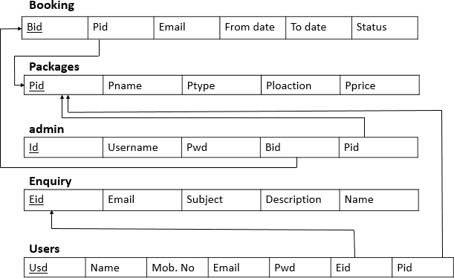

##### Fig 4.4: Schema Diagram of Tourism Management System

A schema contains schema objects, which could be tables, columns, data types, views, stored procedures, relationships, primary keys, foreign keys, etc. A database schema can be represented in a visual diagram, which shows the database objects and their relationship with each other. Here fig. 4.4 shows the schema of Tourism Management System. Bookings, packages, admin, enquiry, users are the tables of the database.

**CHAPTER – 5**

# SOFTWARE AND HARDWARE REQUIREMENT

We have mentioned software and hardware requirement specification of our project.

### Software requirements

* + - Operating system : Windows XP SP3+ or any high versions
    - Platform : WAMP/XAMP
    - Sever side :
      * Apache Server
      * PHP programming language
    - Client side :
      * Browser-Google Chrome, Mozilla FireFox
      * HTML, CSS, JavaScript
      * Database : MySQL

### Hardware requirements

* + - Processor : Pentium 233-meghahertz(MHz).
    - Hard Disk : Minimum 1.5GB Recommended.
    - RAM : Minimum 1GB Recommended.

**CHAPTER – 6**

# IMPLEMENTATION

## Code for displaying Package List

<?php session_start(); error_reporting(0);

include('includes/config.php');

?>

<!DOCTYPE HTML>

<html>

<head>

<title>Package List</title>

<meta name="viewport" content="width=device-width, initial-scale=1">

<meta http-equiv="Content-Type" content="text/html; charset=utf-8" />

<script type="applijewelleryion/x-javascript"> addEventListener("load", function() { setTimeout(hideURLbar, 0); }, false); function hideURLbar(){ window.scrollTo(0,1); }

</script>

<link href="css/bootstrap.css" rel='stylesheet' type='text/css' />

<link href="css/style.css" rel='stylesheet' type='text/css' />

<link href='//fonts.googleapis.com/css?family=Open+Sans:400,700,600' rel='stylesheet' type='text/css'>

<link href='//fonts.googleapis.com/css?family=Roboto+Condensed:400,700,300' rel='stylesheet' type='text/css'>

<link href='//fonts.googleapis.com/css?family=Oswald' rel='stylesheet' type='text/css'>

<link href="css/font-awesome.css" rel="stylesheet">

<!-- Custom Theme files -->

<script src="js/jquery-1.12.0.min.js"></script>

<script src="js/bootstrap.min.js"></script>

<!--animate-->

<link href="css/animate.css" rel="stylesheet" type="text/css" media="all">

<script src="js/wow.min.js"></script>

<script>

new WOW().init();

</script>

</head>

<body>

<?php include('includes/header.php');?>

<!--- banner >

<div class="banner-3">

<div class="container">

<h1>Package List</h1>

</div>

</div>

<!--- /banner >

<!--- rooms >

<div class="rooms">

<div class="container">

<div class="room-bottom">

<h3>Package List</h3>

<?php $sql = "SELECT * from tbltourpackages";

$query = $dbh->prepare($sql);

$query->execute();

$results=$query->fetchAll(PDO::FETCH_OBJ);

$cnt=1;

if($query->rowCount() > 0)

{

foreach($results as $result)

{ ?>

<div class="rom-btm">

<div class="col-md-3 room-left wow fadeInLeft animated" data-wow-delay=".5s">

<img src="admin/pacakgeimages/<?php echo htmlentities($result-

>PackageImage);?>" class="img-responsive" alt="">

</div>

<div class="col-md-6 room-midle wow fadeInUp animated" data-wow- delay=".5s">

<h4>Package Name: <?php echo htmlentities($result-

>PackageName);?></h4>

<h6>Package Type : <?php echo htmlentities($result->PackageType);?></h6>

<p><b>Package Location :</b> <?php echo htmlentities($result-

>PackageLocation);?></p>

</div>

<div class="col-md-3 room-right wow fadeInRight animated" data-wow-delay=".5s">

<h3>Rs <?php echo htmlentities($result->PackagePrice);?></h3>

<a href="package-details.php?pkgid=<?php echo htmlentities($result->PackageId);?>" class="view">Details</a>

</div>

<div class="clearfix"></div>

</div>

<?php }} ?>

</div>

</div>

</div>

<?php include('includes/footer.php');?>

<?php include('includes/signup.php');?>

<?php include('includes/signin.php');?>

<?php include('includes/write-us.php');?>

</body>

</html>

This is the code to display the package list to the users. The users here can view the package name, package type, package location and the cost of the package. This code consist of HTML, PHP as well as Java Script which are necessary to the functioning of the page.

## CHAPTER – 7

* 1. **Results**

# RESULTS & TESTING

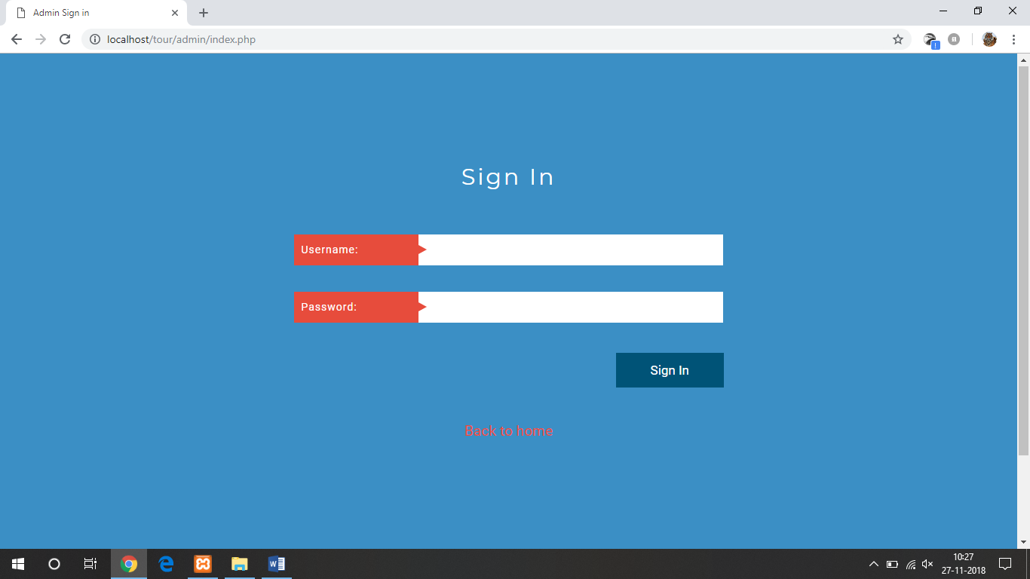

##### Fig 7.1 Admin Sign in Page

Fig. 7.1 is the admin sign in page, where the valid username and the password takes the admin to the admin home page. The user can also go back to the home page from this page.

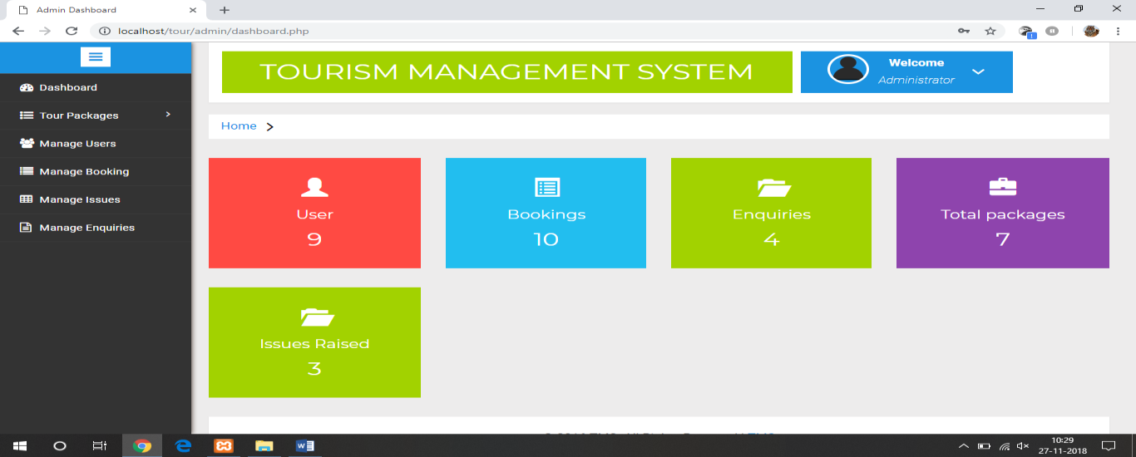

##### Fig 7.2: Admin home page

The admin home page (fig 7.2) mainly consist of the dashboard, and details about the users, bookings, enquires, packages and issues that are raised. The dashboard gives the admin the privilage to create and manage the packages, manage the users and their bookings and also to manage the enquries.

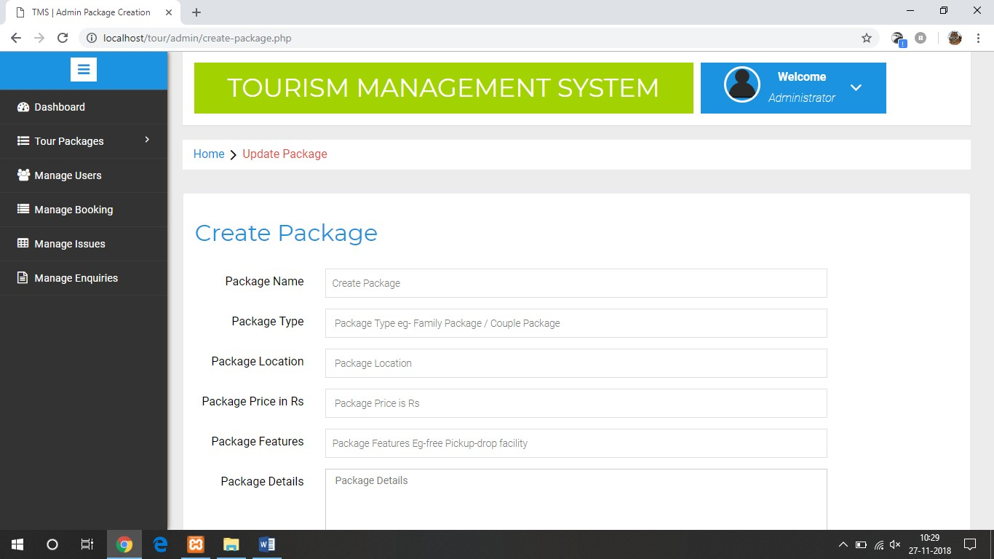

##### Fig 7.3: Page to create packages

Fig 7.3 is the page used by the admin to create the tour packages. Here the admin enters the information of the packages such as package name, type, location, price, and features along with a relevant images. Then by a click on ‘create’ button the package is created.

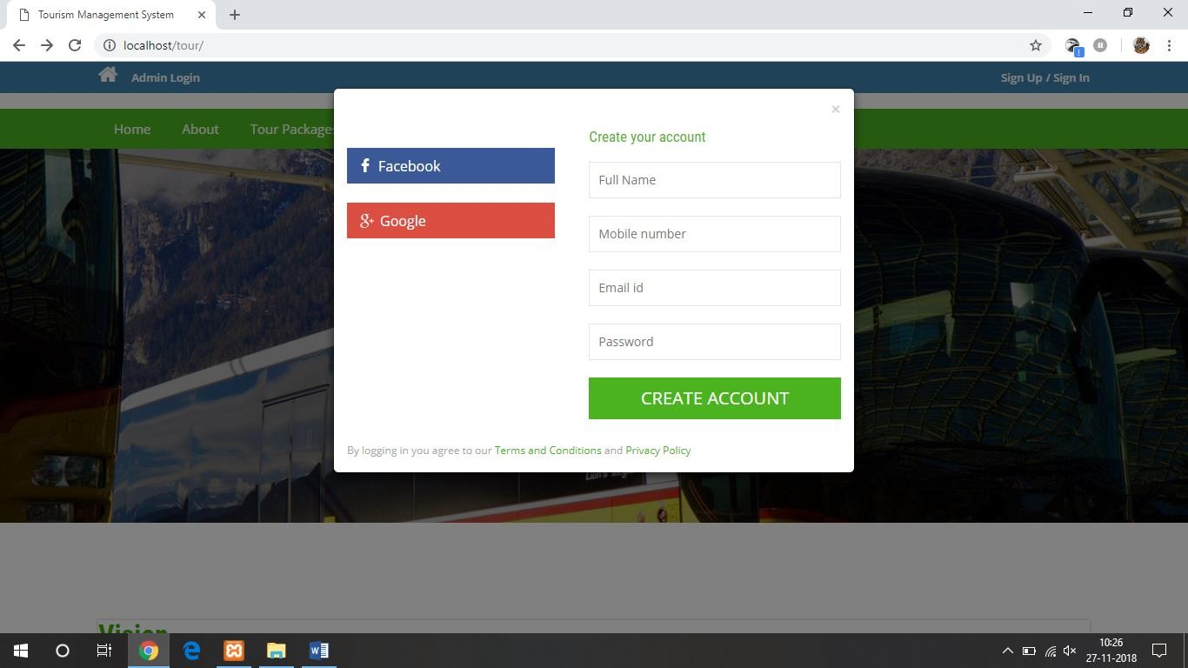

##### Fig 7.5: User Sign Up page

Fig 7.5 illustrates the page where the new users of the website are privileged to register themselves by signing up to the site. The users are made to give the details like their name, phone number, mail id and password. Their account is then created by clicking on ‘CREATE ACCOUNT’ button.

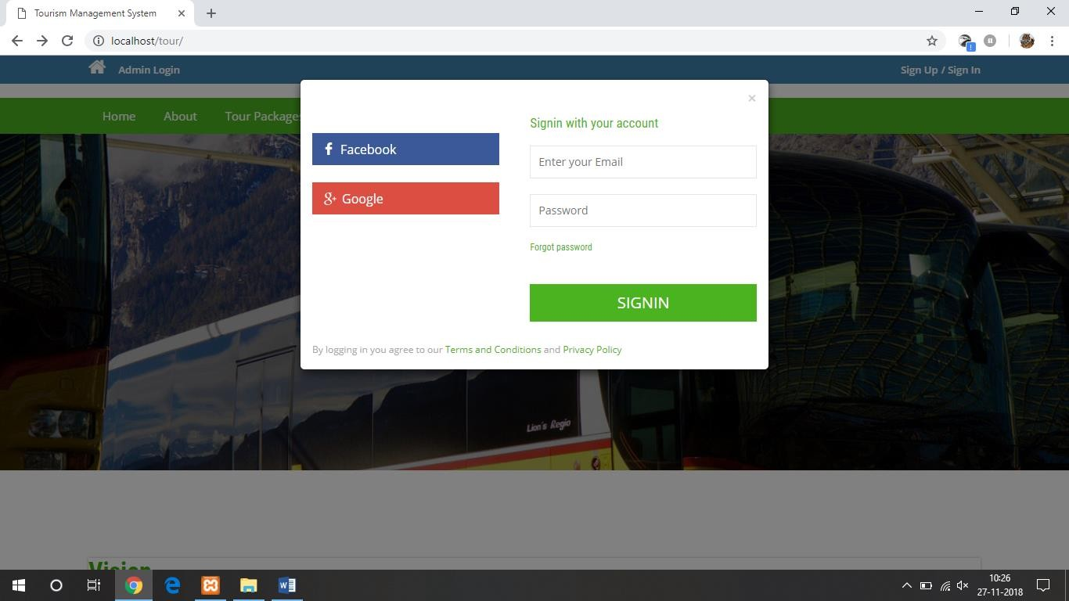

##### Fig 7.6: User Sign In page

The users who already has an account can sign in via this page as show in fig 7.6. The users are requested to enter their email and password. They can even sign in through facebook and google.

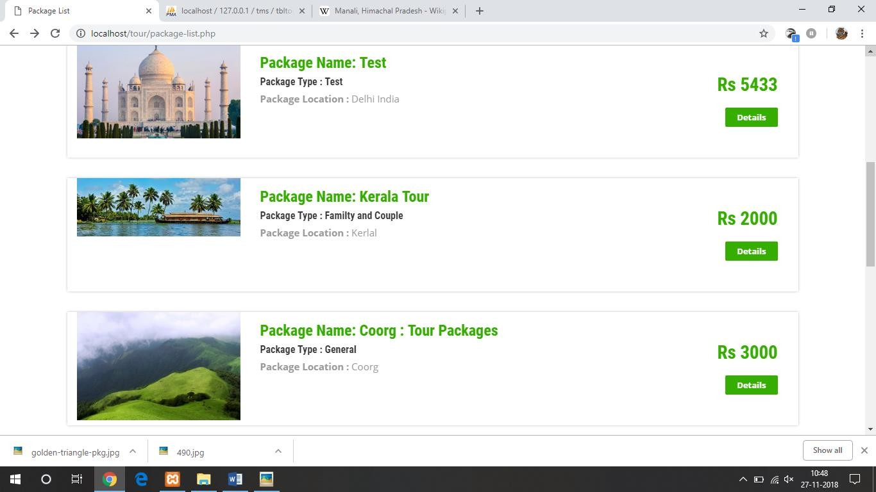

##### Fig 7.7: Page to display the list of tour packages

Fig. 7.7 is the page that displays the list of all the tour packages which are created the admin. It displays the image of the package with the name, type, location and the cost. The user can also view other details by clicking on ‘Details’ button.

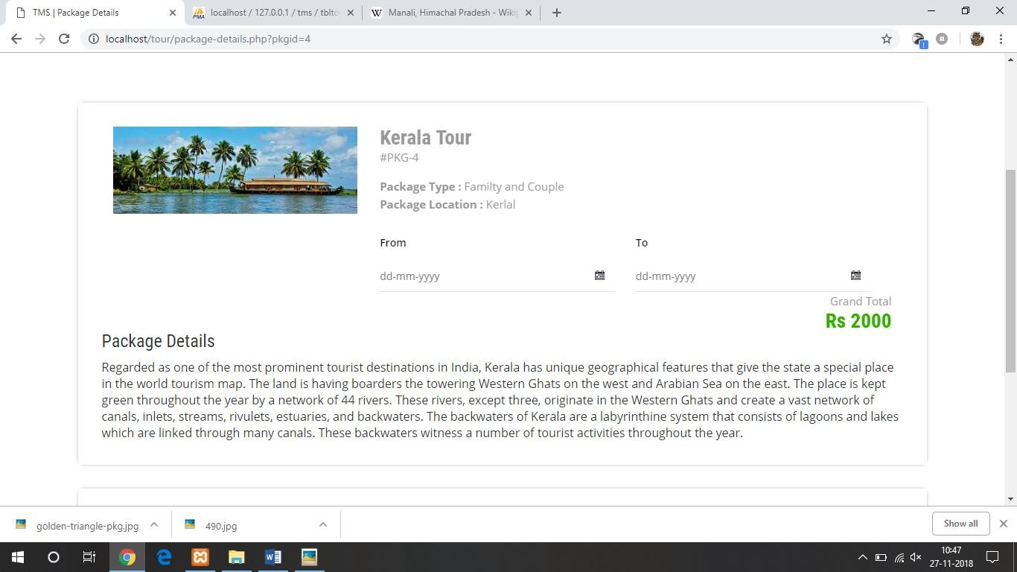

##### Fig 7.8: Page displaying the details of the package

Fig 7.8 depicts where the users are privileged to view the complete details of the package that they have selected and book that package for any number of days as they wish.

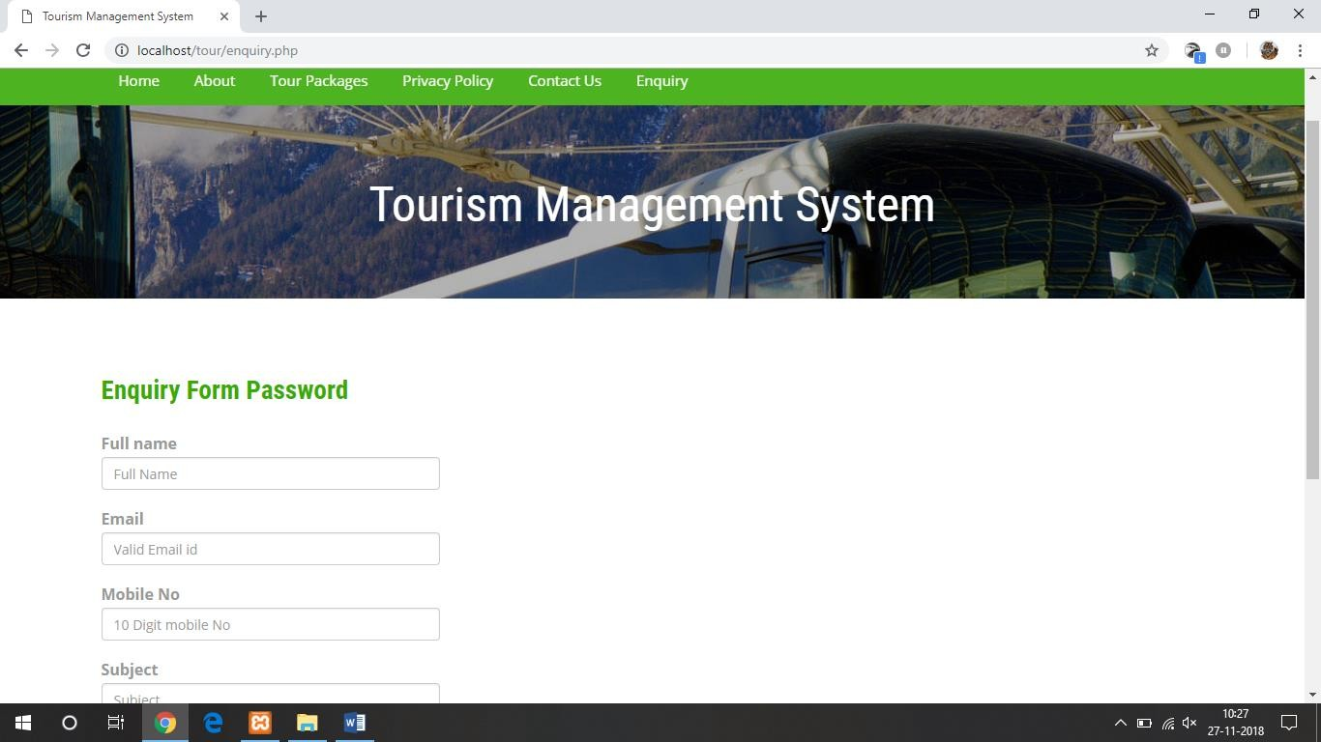

##### Fig 7.9: Users enquiry page

The users can also arise their issues and enquires in this page as shown in fig 7.9. The details of the user and the description along with the subject is made to enter. Then this enquiry is viewed and managed by the admin.

* 1. **Testing**

**Software Testing:** It is a process, to evaluate the functionality of a software application with an intent to find whether the developed software met the specified requirements or not and to identify the defects to ensure that the product is defect free in order to produce the quality product.

#### Types of Testing:

* + 1. Unit testing:

Unit Testing is done to check whether the individual modules of the source code are working properly. i.e. testing each and every unit of the application separately by the developer in developer’s environment. It is AKA Module Testing or Component Testing

* + 1. Integration testing:

Integration testing is a level of software testing where individual units are combined and tested as a group. The purpose of this level of testing is to expose faults in the interaction between integrated units.

|  |  |  |  |  |
| --- | --- | --- | --- | --- |
| **Test case ID** | **Test Case** | **Expected output** | **Actual output** | **Remarks** |
| T01 | Verify username for 8  to 15 characters | Verify | Verified | Done |
| T02 | Verify password for 15 to 20 characters | Verify | Verified | Done |
| T03 | Verify login to redirect to admin page | Verify | Verified | Done |

|  |  |  |  |  |
| --- | --- | --- | --- | --- |
| T04 | Booking packages by more than 15 users | Book | Booked | Done |
| T05 | Issues generation by more than 15 users | Generation | Generated | Done |
| T06 | Verify by giving invalid password | Verify | Verified | Done |
| T07 | Adding more than 20 packages | Add | Added | Done |
| T08 | Verify email for 10 to 15 characters | Verify | Verified | Done |

**CHAPTER – 8**

# CONCLUSION AND FUTURE ENHANCEMENTS

Tourism is currently recognized as a global industry which is highly growing at a high rate, and like any industry that grows rapidly, the activities of tourism can have a substantial impact on the local development processes. Tourism management System proves to be a strong system which has followed almost all the industrial standards.

It’s a web-enabled mini project. This mini project offers user to enter the data through simple and interactive forms. This is very helpful for the client to enter the desired information through so much simplicity. In this website, user can go through the list of tour packages in the and book those packages. The user is mainly more concerned about the validity of the data, whatever he is entering. There are checks on every stages of any new creation, data entry or updation so that the user cannot enter the invalid data, which can create problems at later date. Data storage and retrieval will become faster and easier to maintain because data is stored in a systematic manner and in a single database.

Decision making process would be greatly enhanced because of faster processing of information since data collection from information available on computer takes much less time than manual system. As the database is created with the good design, the system can comply with any demand in the future.

# REFERENCES

1. Randy Connolly, Ricardo Hoar, "Fundamentals of Web Development”, 1stEdition,

Pearson Education India, 2002.

1. https:/[/www.w3schools.com](http://www.w3schools.com/)
2. [www.indiatravelblog.com](http://www.indiatravelblog.com/)
3. https:/[/www.make](http://www.makemytrip.com/)m[ytrip.com](http://www.makemytrip.com/)
4. https:/[/www.trivago.in](http://www.trivago.in/)

# APPENDIX

* + PHP: Hypertext Preprocessor
  + SQL: Structured Query Language
  + HTML: Hypertext Markup Language